Paper Title

Full First Author^{1*}, Full Second Author², Full Third Author^{1, 2}
¹ Department/Faculty/School, University, city postcode, state, nationality.
² The second affiliation and address.

* Corresponding author. email: ???
Manuscript submitted January 10, 2022; revised May 8, 2022; accepted June 10, 2022; published Month date, Year.
doi: ???

Abstract: These instructions give you guidelines for preparing papers for International Journal of Smart Grid and Clean Energy. Define all symbols used in the abstract. Do not cite references in the abstract.

Key words: About four key words or phrases in alphabetical order, separated by commas.

Introduction
(10.5 pt) Here introduce the paper, and put a nomenclature, if necessary, in a box with the same font size as the rest of the paper. The paragraphs continue from here and are only separated by headings, subheadings, images and formulae. The section headings are arranged by numbers, bold and 12 pt.
Do not change the font sizes or line spacing to squeeze more text into a limited number of pages. Use italics for emphasis; do not underline.
To insert images in Word, position the cursor at the insertion point and either use Insert | Picture | From File or copy the image to the Windows clipboard and then Edit | Paste Special | Picture (with “Float over text” unchecked).
IJSGCE reserves the right to do the final formatting of your paper.

Structure
Files should be in MS Word format only and should be formatted for direct printing. Figures and tables should be embedded and not supplied separately. Please make sure that you use as much as possible normal fonts in your documents. Special fonts, such as fonts used in the Far East (Japanese, Chinese, Korean, etc.) may cause problems during processing. To avoid unnecessary errors, you are strongly advised to use the ‘spellchecker’ function of MS Word. Follow this order when typing manuscripts: Title, Authors, Affiliations, Abstract, Keywords, Main text (including figures and tables), Acknowledgements, References, Appendix. Collate acknowledgements in a separate section at the end of the article and do not include them on the title page, as a footnote to the title or otherwise.
Bulleted lists may be included and should look like this:
- First point
- Second point
- And so on
Please do not alter the formatting and style layouts which have been set up in this template document. As indicated in the template, papers should be prepared in single column format suitable for direct printing onto A4 paper (192 mm262 mm). Do not number pages on the front, as page numbers will be added separately for the preprints and the Journal. All the required style templates are provided in this document; please follow them in preparing your manuscript.

Section headings
Section headings should be left justified, with the first letter capitalized and numbered consecutively, starting with the Introduction. Sub-section headings should be in capital and lower-case bold letters, numbered 1.1, 1.2, etc, and left justified.

General guidelines for the preparation of your text
Avoid hyphenation at the end of a line. Symbols denoting vectors and matrices should be indicated in bold type. Scalar variable names should normally be expressed using italics. Weights and measures should be expressed in SI units.

Footnotes
Footnotes should be avoided. Necessary “footnotes” should be composed directly in the text, instead of footnote style.

Author Artwork

Figures
All figures should be numbered with Arabic numerals (1, 2, ..., n). All photographs, schemas, graphs and diagrams are to be referred to as figures. Line drawings should be good quality scans or true electronic output. Low-quality scans are not acceptable. Figures must be embedded into the text and not supplied separately. Lettering and symbols should be clearly defined either in the caption or in a legend provided as part of the figure. Figures should be placed at the top or bottom of a page wherever possible, as close as possible to the first reference to them in the paper.
The figure number and caption should be typed below the illustration in 9pt and left justified. However, if two images fit next to each other, these may be placed next to each other to save space, see Fig. 1. Use the abbreviation “Fig.” even at the beginning of a sentence. They must be numbered consecutively.
Figure axis labels are often a source of incompleteness. All coordinate graphs should have the axis labels: physical quantity with unit in parentheses, as shown in Fig. 1.

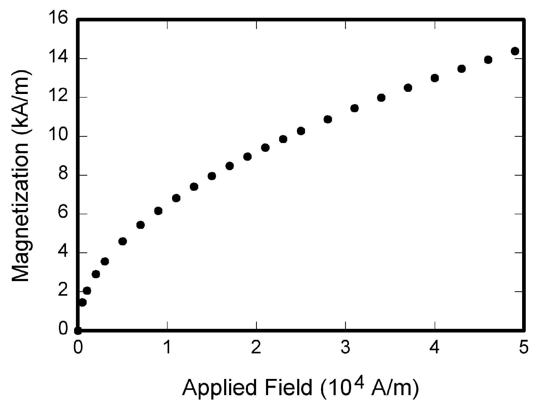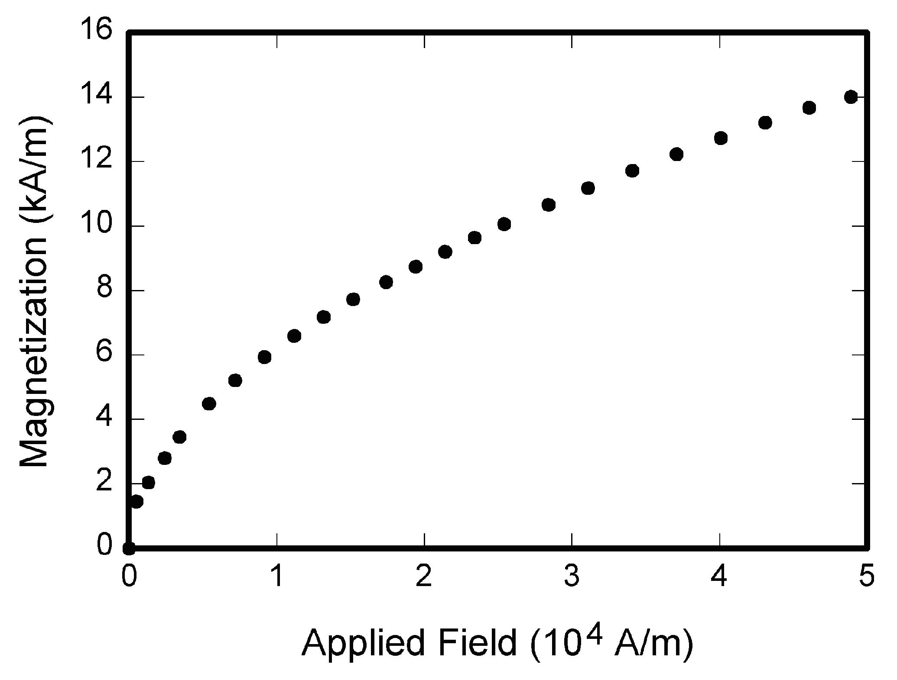
(a) (b)
Fig. 1. Magnetization as a function of applied field: (a) condition 1and (b) condition 2.

Tables
Tables are numbered with Arabic numerals in sequential numerical order, and all the Tables should be mentioned in numerical order in the main text (see Table 1).
Table 1. An example of a table
Channels | Group 1 | Group 2 | … | Group c
Main channel | Channel 1 | Channel 2 | … | Channel c
Assistant channel | Channel 2 | Channel 3 | … | Channel 1

Equations
If you are using Word, use either the Microsoft Equation Editor or the MathType add-on (http://www.mathtype.com) for equations in your paper (Insert | Object | Create New | Microsoft Equation or MathType Equation). “Float over text” should not be selected.
Number equations consecutively with equation numbers in parentheses flush with the right margin, as in Eq. (1). First use the equation editor to create the equation. Then select the “Equation” markup style. Press the tab key and write the equation number in parentheses. To make your equations more compact, you may use the solidus ( / ), the exp function, or appropriate exponents. Use parentheses to avoid ambiguities in denominators. Punctuate equations when they are part of a sentence, as in:
(1)
Be sure that the symbols in your equation have been defined before the equation appears or immediately following. Italicize symbols (T might refer to temperature, but T is the unit tesla). Refer to “Eq. (1)”, using the abbreviation “Eq.” even at the beginning of a sentence.

Units
Use either SI (MKS) or CGS as primary units. (SI units are strongly encouraged.) English units may be used as secondary units (in parentheses). This applies to papers in data storage. For example, write “15 Gb/cm² (100 Gb/in²).” An exception is when English units are used as identifiers in trade, such as “3½ in disk drive.” Avoid combining SI and CGS units, such as current in amperes and magnetic field in oersteds. This often leads to confusion because equations do not balance dimensionally. If you must use mixed units, clearly state the units for each quantity in an equation.
The SI unit for magnetic field strength H is A/m. However, if you wish to use units of T, either refer to magnetic flux density B or magnetic field strength symbolized as µ₀H. Use the center dot to separate compound units, e.g., “A·m².”

Helpful Hints

References
Number citations consecutively in square brackets [1]. The sentence punctuation follows the brackets [2]. Multiple references [2, 3] are numbered within one bracket [1–3]. When citing a section in a book, please give the relevant page numbers [2]. In sentences, refer simply to the reference number, as in [3]. Do not use “Ref. [3]” or “reference [3]” except at the beginning of a sentence: “Reference [3] shows ... .”
Some examples of how your references should be listed are given at the end of this template in the ‘References’ section which will allow you to assemble your reference list according to the correct format and font size. There is a shortened form for more than three authors, the first three names should be listed and then followed by “et al.”.

Abbreviations and Acronyms
Define abbreviations and acronyms the first time they are used in the text, even after they have already been defined in the abstract. Abbreviations that incorporate periods should not have spaces: write “C.N.R.S.,” not “C. N. R. S.” Do not use abbreviations in the title unless they are unavoidable.

Other Recommendations
Use one space after periods and colons. Hyphenate complex modifiers: “zero-field-cooled magnetization.” Avoid dangling participles, such as, “Using (1), the potential was calculated.” [It is not clear who or what used (1).] Write instead, “The potential was calculated by using (1),” or “Using (1), we calculated the potential.”
Use a zero before decimal points: “0.25,” not “.25.” Use “cm³,” not “cc.” Indicate sample dimensions as “0.1 cm × 0.2 cm,” not “0.1 × 0.2 cm².” The abbreviation for “seconds” is “s,” not “sec.” Do not mix complete spellings and abbreviations of units: use “Wb/m²” or “webers per square meter,” not “webers/m².” When expressing a range of values, write “7 to 9” or “7–9,” not “7~9.”
A parenthetical statement at the end of a sentence is punctuated outside of the closing parenthesis (like this). (A parenthetical sentence is punctuated within the parentheses.) In American English, periods and commas are within quotation marks, like “this period.” Other punctuation is “outside”! Avoid contractions; for example, write “do not” instead of “don’t.” The serial comma is preferred: “A, B, and C” instead of “A, B and C.”
If you wish, you may write in the first person singular or plural and use the active voice (“I observed that ...” or “We observed that ...” instead of “It was observed that ...”). Remember to check spelling. If your native language is not English, please get a native English-speaking colleague to proofread your paper.

Some Common Mistakes
The word “data” is plural, not singular. The subscript for the permeability of vacuum µ₀ is zero, not a lowercase letter “o.” The term for residual magnetization is “remanence”; the adjective is “remanent”; do not write “remnance” or “remnant.” Use the word “micrometer” instead of “micron.” A graph within a graph is an “inset,” not an “insert.” The word “alternatively” is preferred to the word “alternately” (unless you really mean something that alternates). Use the word “whereas” instead of “while” (unless you are referring to simultaneous events). Do not use the word “essentially” to mean “approximately” or “effectively.” Do not use the word “issue” as a euphemism for “problem.” When compositions are not specified, separate chemical symbols by en-dashes; for example, “NiMn” indicates the intermetallic compound Ni_{0.5}Mn_{0.5} whereas “Ni–Mn” indicates an alloy of some composition Ni_{x}Mn_{1-x}.
Be aware of the different meanings of the homophones “affect” (usually a verb) and “effect” (usually a noun), “complement” and “compliment,” “discreet” and “discrete,” “principal” (e.g., “principal investigator”) and “principle” (e.g., “principle of measurement”). Do not confuse “imply” and “infer.”
Prefixes such as “non,” “sub,” “micro,” “multi,” and “"ultra” are not independent words; they should be joined to the words they modify, usually without a hyphen. There is no period after the “et” in the Latin abbreviation “et al.” (it is also italicized). The abbreviation “i.e.,” means “that is,” and the abbreviation “e.g.,” means “for example” (these abbreviations are not italicized).

Conclusion
A conclusion section is not required. Although a conclusion may review the main points of the paper, do not replicate the abstract as the conclusion. A conclusion might elaborate on the importance of the work or suggest applications and extensions.
Appendix
Appendixes, if needed, appear before the acknowledgment. Multiple appendices should all have headings in the style used above. They will automatically be ordered A, B, C etc.
Conflict of Interest
Please declare whether or not the submitted work was carried out with a conflict of interest. If yes, please state any personal, professional or financial relationships that could potentially be construed as a conflict of interest. If no, please add "The authors declare no conflict of interest".
Author Contributions
Please state each author's contribution to this work, it can be up to several sentences long and should briefly describe the tasks of individual authors. The following statements should be used “Conceptualization, X.X. and Y.Y.; methodology, X.X.; software, X.X.; validation, X.X., Y.Y. and Z.Z.; formal analysis, X.X.; investigation, X.X.; resources, X.X.; data curation, X.X.; writing—original draft preparation, X.X.; writing—review and editing, X.X.; visualization, X.X.; supervision, X.X.; project administration, X.X.; funding acquisition, Y.Y. All authors had approved the final version.”
Funding
Please add: “This research received no external funding” or “This research was funded by NAME OF FUNDER grant number XXX.” and “The APC was funded by XXX”. Check carefully that the details given are accurate and use the standard spelling of funding agency names, any errors may affect your future funding.
Acknowledgment
The preferred spelling of the word “acknowledgment” in American English is without an “e” after the “g.” Use the singular heading even if you have many acknowledgments. Avoid expressions such as “One of us (S.B.A.) would like to thank ... .” Instead, write “The first author thanks ... .”.
References
(Book)
- American Psychological Association. (2001). Publication Manual of the American Psychological Association (5th ed.). Washington, D.C.: Publisher.
- Moore, M. H., Estrich, S., McGillis, D., & Spelman, W. (1984). Dangerous Offenders: The Elusive Target of Justice. Cambridge: Harvard University Press.
- Strunk, W., & White, E. B. (1979). The Elements of Style (3rd ed.). New York: Macmillan.
(Chapter in Edited book)
- Vygotsky, L. S. (1991). Genesis of the higher mental functions. In P. Light, S. Sheldon, & M. Woodhead (Eds.), Learning to Think (pp. 32–41). London: Routledge.
(Report/working paper etc.)
- Birney, A. J., & Hall, M. M. (1981). Early Identification of Children with Written Language Difficulties (Report No. 81–502). Washington D.C.: National Educational Association.
(Conference paper in published proceedings)
- Borgman, C. L., Bower, J., & Krieger, D. (1989). From hands-on science to hands-on information retrieval. In J. Katzer, & G. B. Newby (Eds.), Proceedings of the 52nd ASIS Annual Meeting: Vol. 26. Managing Information and Technology (pp. 96–100). Medford, NJ: Learned Information.
(Journal article)
- Noguchi, T., Kitawaki, J., Tamura, T., et al. (1993). Relationship between aromatase activity and steroid receptor levels in ovarian tumors from postmenopausal women. Journal of Steroid Biochemistry and Molecular Biology, 44(4–6), 657–660.
(Journal article (only electronic/online))
- Korda, L. (2001, July). The making of a translator. Translation Journal, 5(3). Retrieved August 21, 2001, from http://accurapid.com/journal/17prof.htm.
(Dissertation)
- Hardman, J. P. (1999). Rainer Werner Fassbinder’s BRD Trilogy: A Manifesto for Social and Political Reform. Unpublished undergraduate dissertation, University of Portsmouth, Portsmouth.
(E-Book)
- Harris, J., & Grace, S. (1999). A question of evidence? Investigating and Prosecuting Rape in the 1990s (Home Office Research Study 196). Retrieved July 19, 2004, from the UK Home Office website: http://www.homeoffice.gov.uk/rds/pdfs/hors196.pdf
(Newspaper article)
- Caffeine linked to mental illness. (1991, July 13). New York Times, pp. B13, B15
(Government publication and regulations)
- Great Britain. Command Papers. (1991). Health of the Nation (Cm 1523). London: HMSO.
- Department of Education, Science & Training. (2000). Annual Report 1999-2000. AGPS, Canberra.

Copyright © 2023 by the authors. This is an open access article distributed under the Creative Commons Attribution License (CC BY-NC-ND 4.0), which permits use, distribution and reproduction in any medium, provided that the article is properly cited, the use is non-commercial and no modifications or adaptations are made.

